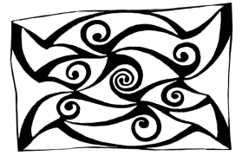
Ulster Place-Name Society Newsletter
14 May 2019

UPNS Spring Lecture: Richard Warner (retired Keeper of Archaeology & Ethnography at the Ulster Museum) will talk on Ptolemy’s Ireland on Thursday 23rd May 2019 at 8pm in Room 18, Floor 2 (0218) of the Peter Froggatt Centre, Queen’s University of Belfast.

Warner will attempt to rescue the Irish portion of the brilliant cartographic project of the 2nd century Alexandrian genius, Claudius Ptolemaeus, from the unjustified ‘correcting’-activities of modern scholars. He will shine an archaeological light on the details of Ptolemy’s map of Ireland and will eschew the popular use of linguistic word-play and clever mathematics. He will attempt to show how Ptolemy compiled the map and will make what he hopes are reasonable identifications of the places and peoples he listed. He will show that for Ireland, surprisingly considering its claimed cultural and linguistic continuity, a smaller proportion of names can be identified in later sources than in the rest of western Europe.
Membership Renewal: Members who renew their membership in spring are reminded to do so; the fee is £10/€14 and £15/€20 for institutions. You can now pay your membership online at https://www.ulsterplacename.org/member-details
Activities
Northern Ireland Place-Name Project (www.placenamesni.org)
NIPNP is currently in the second year of its three years of funding from the Department of Finance. In the past six months, the focus of the work has moved to the townlands of south Tyrone and latterly Fermanagh. Provisional suggestions as to the origins of these names are uploaded regularly on to the website and Frances Kane has also initiated an extremely active twitter account which has been receiving a lot of positive feedback. The account currently has approximately 1,200 followers and a name of interest is tweeted every day by Frances accompanied by wonderful visual images! Please follow us at @placenamesni
Glens Place-names Project January-March 2019
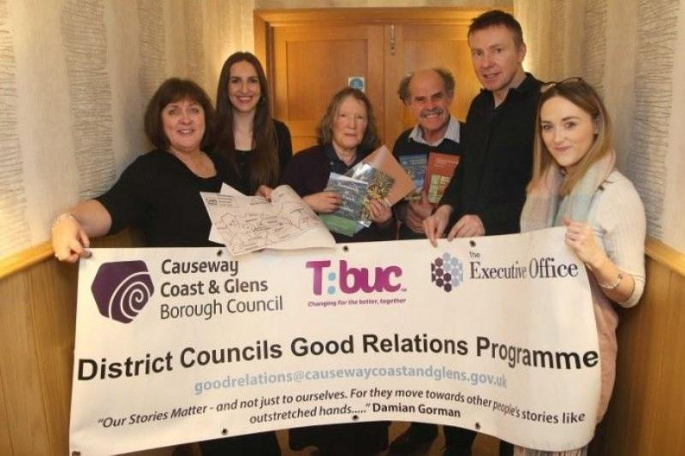
This project was initiated by Joy Wisener and Amy McWilliams of Causeway Coast and Glens Council, as part of the good relations outreach of the council. It involved Pat, Kay and Gordon giving presentations on place-names, maps, folklore, and material from the Ordnance Survey Memoirs in Cushendun, Ballycastle and Rathlin. Locals corrected or verified our pronunciations of local place-names and contributed a great deal of information. In one remarkable moment in Cushendun we heard an entirely new story about the Cross na Naghen in Layde churchyard. On Rathlin we were given many hitherto unrecorded explanations of local place-names by John McFaul, a local boatman.
Council employees gave participants access to online material which is available to local government, but not to members of the general public. An innovative part of the project was to encourage locals to carry out on-line research by themselves during the sessions. This approach was used by Gordon in subsequent cross-community work in Banbridge High School and St Patrick’s Academy, and a Derry cross-community group have expressed interest in a similar project.
Pat McKay, Pádraig Ó Cearbhaill and Frances Kane attended the Society for Name Studies in Britain and Ireland (SNSBI) conference in Nottingham at the end of April. Frances gave a presentation on the Scottish influence on the place-names of Co. Antrim, and Pádraig gave a talk on Irish place-name elements associated with death including tuaim ‘burial mound’, feart ‘grave, grave monument’ and leacht ‘grave monument’.
Kay Muhr gave a talk on local place-names (including minor names connected with St Lúrach) in Maghera on March 28th (Maghera Heritage Project); and on April 26th, on the Function of Names in Gaelic Storytelling at a conference on Tales and Transmission (Ireland and Scotland) at the Dept of Anglo-Saxon, Norse and Celtic in Cambridge. She will be talking on Lecale place-names to the Lecale Historical Society in Down County Museum on September 16th and on Place-names and Boundaries at an Ulster Local History Trust day conference on Borders and Boundaries in Armagh on October 19th.
Kay is continuing her work with Liam Ó hAisibéil on the Oxford University Press publication on the family names of Ireland.
Gordon is continuing his work on a Gaelic Map of Belfast for Belfast City Council, which he hopes to launch during Community Relations Week in September 2019.
Pat continues to provide Irish-language versions of road names and townland names for Mid-Ulster Council. He has also supplied Irish-language versions of the names of the townlands of the parish of Dromore in Co. Tyrone for a local signage project, drawing on fieldwork carried out a few years ago by Kay Muhr and her husband Brian Lambkin. He has been invited to give a talk on the place-names of the local area at the end of July.
UPNS Autumn Lecture 2018: Dr Kevin Murray, of University College Cork, gave a presentation to the society on Dinnshenchas as an Onomastic Resource on Thursday 29th November 2018.
Murray’s talk concerned the Version C Dinnsenchas from the Book of Ballymote and the Bibliothèque de Rennes Métropole in the light of his work on the Historical Dictionary of Gaelic Placenames. Version C Dinnsenchas is prosometric in form – the place-names are explained in both prose and poetic forms. Although these works date from the late 12th and early 13th centuries, both the formulaic linguistic styles and content relate to earlier forms of the Irish language and early mythological themes rather than contemporary issues.
Most of the place-names refer to natural formations as well as man-made features such as áth (ford), ard (height) carn (cairn) dún (fort), loch (lake) mag (plain) and sliab (mountain). Although a number of well-known place-names are mentioned e.g. Temair (Tara) and Bóand (Boyne), many sites of contemporary political and ecclesiastical importance are notably absent. Furthermore, there are no place-names with common elements such as achad (field), baile (homestead) and dísert (hermitage).
Murray finds that onomastics and political geography play a less important role in dinnsenchas than immanence, or the elaboration of mythological themes in geographical terms. These themes would have been well-known to readers or hearers of the material. Many of the places mentioned commemorate the place where someone died or was killed in battle. Murray gave two examples of place-names which cannot be located, and probably never existed, although the myths associated with them are well-known: Leacht Óenfhir Aífe (the funeral stone of Aífe’s only son) and Carrac Leithdeirg (‘the rock of Leithdeirg’). Murray finds material related to well-known place-names to be opportunistic post-rationalisations. For example, the origin of the name of Loch Cé is attributed to an otherwise unattested Cé, a druid, who was involved in the battle of Magh Turedh. The function of this tale is to relate the battle site to the lake, which is ten miles away.
Murray cited a further example from the north. The source of Ráth mór Maige Line, the royal seat of the Dál nAraide, is related to Bresal Brec, who embarks on a 50-year adventure under Loch Laíg (Belfast Lough). On hearing he will never return, his wife Mór falls dead, and is commemorated in the name of Ráth Mór. Murray finds this doubtful, as one would expect the inflexion of this female name to result in Ráth Móire, and there is a Ráth Beag (‘small fort’) nearby.
Murray finds 40% of the place-names of the Rennes material to be unattested outside the dinnsenchas, and of the 60% of the place-names which are attested elsewhere, 20% cannot be identified. Of the total of 156 names in the Rennes material, 47 % cannot be located. Murray is doubtful of the usefulness of the dinnsenchas in terms of onomastics and finds the greatest contribution of this material to be in terms of mythology. While some well-known themes are re-iterated in dinnseanchas, much additional material could add to our knowledge of these myths.
Gordon McCoy, Mícheál Ó Mainnín, Greg Toner, Kay Muhr, Pat McKay, UPNS c/o Irish and Celtic Studies, School of Modern Languages, QUB BT7 1NN

Email: townlands.upns@gmail.com

Website: www.ulsterplacename.org

See also: www.placenamesni.org and www.logainm.ie

